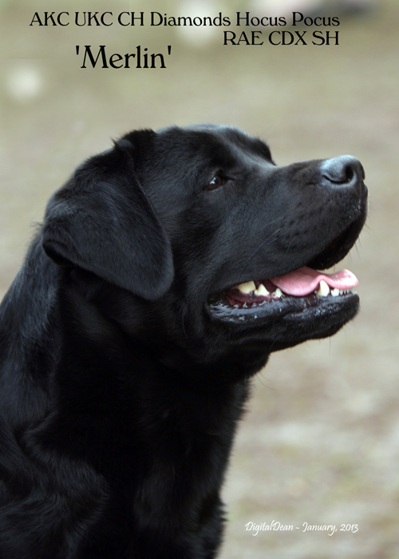
Diamond Labradors
Ken & Gerry Cochran
76 Apple Blossom Place Dayton, OH 45440
email: bbuohio@sbcglobal.net
webpage: www.digitaldean.net/diamond/

STUD AGREEMENT

SIRE: AKC UKC Diamond’s Hocus Pocus RAE CDX SH AKC # SR61709401 COLOR: Black

OWNER(S): Ken A Cochran/Gerry A Cochran/Barb Vincent

STUD FEE: $1200.00
$300.00 Non-Refundable Handling Fee – Up Front
$900.00 Balance Due within 10 days of 3 or more live puppies.
$300.00 Balance Due within 10 days of 2 or less live puppies.

Female must be ovulation timed by quantitative progesterone testing.
Female’s information must be provided including pedigree and health clearances.

- Alternate Plan: Entire fee due by the time of first breeding of the female. There will be no refund of the stud fee
- Repeat breeding is between the named owner of the bitch, named stud and original bitch (exceptions to the original bitch and/or sire can be discussed)
- Repeat breeding must be used within one (1) year of the original breeding.

FRESH CHILLED BREEDING

- Female owner may purchase shipping kit and extender
- One or Two shipments will be made. Arrangements are made in advance.
- Shipping and collection fees must be paid in advance by either a Fed Ex account number or a credit card.
- We are not responsible for any part of the shipping charge, loss of semen during shipping or late arrival. (We strongly suggest that you insure the shipment in order to recover some of your costs should the shipment get lost.)

IN HOUSE BREEDING

Brucellosis is required for in house breeding, which will be a side by side fresh AI.

- We provide two breeding’s, with each successive breeding to occur within 24 to 48 hours of the previous breeding. Ovulation timing is the utmost of importance.
- There is a $20.00 per night boarding fee for breeding females that stay for their breeding. The female must have current vaccinations including Bordetella.

**Bitch owner responsible for all progesterone testing costs
Owner of bitch: ________________________________________________________
Address: __________________________________State______________Zip_________
Telephone: _______________________________ email: ______________________
Bitch owner signature_____________________________________ Date___________

